Epsom & Ewell F.C.
27
v
Camberley Town
Saturday, 16th April 2016 – 3.00 p.m.
Good afternoon! We welcome the players, supporters and officials of our good friends Camberley Town for a League match, together with today’s match officials and our own regular supporters.

I have often referred to us having played Camberley more than any other opponent in our history but few meetings have rivalled this one in terms of importance. For us, I believe a win is essential to remain in touch, but the same is probably true for our visitors as a loss today would leave Ashford as favourites again. They are also chasing a League and Cup double and we wish them luck with the Cup part!

We drew 1-1 at Krooner Park and I thought we actually had the better of the chances, showing great character to come from behind in a game of two penalties. This point was achieved without leading scorer Kyle Hough and we know that if there are opportunities today, he will take them!

On Saturday we hosted Badshot Lea in a must win game, and we did just that with a 4-1 result in our favour. We got off to a flying start and never really looked back. Agi Panayiotou opened the scoring in the fifth minute and with Kyle Hough adding a second before half time it looked very comfortable. A goal for the visitors made the match competitive for a while but Matt Farrell scored twice from Panayiotou assists to finish off any resistance. Then on Tuesday we finally visited AFC Hayes after many postponements, and completely battered the hosts with our second 7-0 away win of the season. We had six different scorers on the night and looked in top form. We’ll find out if that counts for anything today against a much better side than the team we faced on Tuesday.

The end of season is fast approaching. At the ground today we have the Player of the Year forms. Please let us know who you think should be honoured. Additionally, if you are a Club Member, your vote counts double, so remember to fill in that form. We will also be passing them out at the Ashford match, but remember that you can only vote once.

We have just three matches remaining. Next Saturday we visit Hanworth Villa and two weeks today we host Ashford Town (Mx). How important that game will be depends a lot on today’s result but be sure to come along as we will also be producing an extremely large programme issue, full of information and articles about our club to close our home fixtures for the season.

Of course that match was originally due to be our final one of the season, but we now have a trip to Chessington & Hook United to make on Monday 2nd May, with a current kick off time of 11.30. The time and even the venue may yet change, so please keep checking our website for information. We are also off to Chantilly in France in June, and more details will follow next week!

Enjoy the game!

Rich

You can now follow us on Facebook: www.facebook.com/epsomandewellfc Twitter: @EEFCOfficial
and on Instagram at: www.instagram.com/epsomandewellfc

Cover Photos by Gemma Jarman

- Dan Dean (out of picture) scores his first goal for our club at Guildford City
- Tom Neale is about to strike our fifth goal at Guildford City

Cherry Red Records Combined Counties League
Premier Division Table 2015/16
inc Tuesday 12th April | P | W | D | L | F | A | Pts | GD | H | A
Hartley Wintney | 37 | 30 | 4 | 3 | 109 | 35 | 94 | +74 | 0-1 | 3-3
Ashford Town (Mx) | 37 | 26 | 3 | 8 | 98 | 50 | 81 | +48 | 30/4 | 3-2
Camberley Town | 36 | 25 | 6 | 5 | 80 | 32 | 81 | +48 | - | 1-1
Epsom & Ewell | 38 | 24 | 8 | 6 | 93 | 39 | 80 | +54 | x | x
Hanworth Villa | 39 | 21 | 4 | 14 | 72 | 62 | 67 | +10 | 5-0 | 23/4
Horley Town | 37 | 18 | 8 | 11 | 79 | 54 | 62 | +25 | 3-4 | 2-2
Knaphill | 36 | 18 | 4 | 14 | 83 | 58 | 58 | +25 | 1-2 | 1-1
Colliers Wood United | 41 | 17 | 7 | 17 | 76 | 78 | 58 | -2 | 3-1 | 3-0
Spelthorne Sports | 39 | 15 | 10 | 14 | 74 | 75 | 55 | -1 | 2-1 | 6-2
Bedfont Sports | 39 | 14 | 9 | 16 | 64 | 53 | 51 | +11 | 1-0 | 2-2
Raynes Park Vale | 38 | 16 | 3 | 19 | 68 | 76 | 51 | -8 | 3-1 | 3-0
Windsor | 39 | 14 | 9 | 16 | 65 | 75 | 51 | -10 | 2-2 | 1-2
Guildford City | 40 | 15 | 6 | 19 | 73 | 91 | 51 | -18 | 4-0 | 5-1
Farnham Town | 35 | 14 | 7 | 14 | 65 | 58 | 49 | +7 | 1-0 | 2-1
Westfield | 34 | 13 | 8 | 13 | 49 | 56 | 47 | -7 | 0-2 | 0-0
Sutton Common Rovers | 38 | 13 | 5 | 20 | 63 | 77 | 44 | -14 | 3-1 | 2-1
Badshot Lea | 38 | 14 | 2 | 22 | 55 | 93 | 44 | -38 | 4-1 | 1-0
Chertsey Town | 38 | 12 | 7 | 19 | 55 | 69 | 43 | -14 | 0-1 | 5-3
AFC Hayes | 39 | 12 | 7 | 20 | 57 | 81 | 43 | -24 | 1-1 | 7-0
Redhill | 36 | 8 | 5 | 23 | 54 | 77 | 29 | -23 | 3-0 | 1-0
Chessington & Hook Utd | 33 | 8 | 3 | 22 | 48 | 86 | 27 | -38 | 1-0 | 2/5
Cove (R) | 39 | 3 | 1 | 35 | 28 | 133 | 10 | -105 | 1-0 | 7-0

Lucky Day? - 16th April
Played 17 - W 8 D 1 L 8 - F 25 A 21 - PPG 1.47 - Average
Our Club record against Camberley Town
Played 87 - W 38 D 21 L 27 - Abandoned 1
F 156 A 120 - PPG 1.55 - Above Average
Largest wins and losses against Camberley Town
3rd January 1953 - W 9-1 - Surrey Senior Cup (H)
15th April 2006 - L 0-4 - Isthmian League (H)
5th November 2011 - L 0-4 - Combined Counties League (A)
Their Last Visit
Tuesday 24th February 2015 - L 2-4 - Combined Counties League Cup QF

Club Manager – Glyn Mandeville
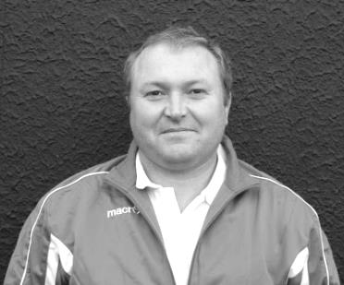
Good afternoon and welcome to High Road for our important match against Camberley Town.

I will start by welcoming all their players/staff and supporters and would like to congratulate you on getting to the League Cup Final and hope you enjoy today's game. Have a safe trip back.

We come into today's game in good form with the last four games producing very good wins. Today's will be very tough and we will need to be at our best to get the three points.

Thanks for your continued support.

Manders

Club Captain - Sam Currie
Good afternoon and welcome to High Road for today’s massive encounter with Camberley Town.

We welcome the squad, management team and fans from Camberley and wish them a safe journey home following the game.

This game comes at a good time for us as we have hit some momentum in the last four games following the disappointing Westfield result.

We have played the four games, scoring 19 goals and picking up maximum points, whilst playing some fantastic football in the process. The latest of these was beating AFC Hayes 7-0 and scoring some impressive goals from a list of different players, which followed up the equally comprehensive win against Badshot Lea here last Saturday.

However, whilst it’s clearly good to be on a run of form going into today’s game, we know the remaining fixtures are so important to the squad and the club and we play two of the teams around us at the top of the table knowing that each game is huge.

Starting with now – Camberley themselves are always well organised and with their own strong win at Ashford on Tuesday (another team at the top) in the League Cup still shows they aren’t showing any signs of slowing up and we know that we have to be at our full potential today.

We drew with them away a few weeks back, but we did come away feeling a little disappointed having created a number of good chances towards the end of the game that could have seen us come away with more.

We hope you enjoy today’s game and for your continued support.

Sam

Latest Results and Fixtures
Combined Counties League – Thursday 7th April
Badshot Lea | 2-4 | Camberley Town
Redhill | 6-0 | Chessington & Hook United
Combined Counties League – Saturday 9th April
Ashford Town (Mx) | 4-1 | Guildford City
Bedfont Sports | 5-0 | Colliers Wood United
Camberley Town | 3-1 | Raynes Park Vale
Chessington & Hook United | 2-1 | AFC Hayes
Epsom & Ewell | 4-1 | Badshot Lea
Farnham Town | 1-3 | Chertsey Town
Hanworth Villa | 2-1 | Cove
Hartley Wintney | 2-2 | Horley Town
Knaphill | 6-1 | Spelthorne Sports
Redhill | 1-1 | Westfield
Sutton Common Rovers | 1-1 | Windsor
Combined Counties League Cup SF – Tuesday 12th April
Ashford Town (Mx) | 0-3 | Camberley Town
Combined Counties League – Tuesday 12th April
AFC Hayes | 0-7 | Epsom & Ewell
Chessington & Hook United | 1-2 | Hartley Wintney
Match played at Molesey F.C. as Chessington’s pitch was waterlogged
Farnham Town | 2-1 | Sutton Common Rovers
Knaphill | 2-4 | Hanworth Villa
Raynes Park Vale | 0-1 | Redhill
Westfield | 2-0 | Horley Town
Combined Counties League – Thursday 14th April
Chessington & Hook United | V | Horley Town
Match switched to Horley Town
Farnham Town | V | Westfield
Combined Counties League – Saturday 16th April
AFC Hayes | V | Sutton Common Rovers
Badshot Lea | V | Knaphill
Chertsey Town | V | Hartley Wintney
Cove | V | Colliers Wood United
Epsom & Ewell | V | Camberley Town
Guildford City | V | Chessington & Hook United
Horley Town | V | Farnham Town
Raynes Park Vale | V | Hanworth Villa
Spelthorne Sports | V | Redhill
Westfield | V | Bedfont Sports
Windsor | V | Ashford Town (Mx)
Combined Counties League Cup SF – Tuesday 19th April
Farnham Town | V | Cobham
Latest Results and Fixtures
Combined Counties League – Tuesday 19th April
AFC Hayes | V | Badshot Lea
Chessington & Hook United | V | Sutton Common Rovers
Raynes Park Vale | V | Camberley Town
Spelthorne Sports | V | Knaphill
Westfield | V | Redhill
Combined Counties League – Thursday 21st April
Chessington & Hook United | V | Westfield
Redhill | V | Ashford Town (Mx)
Combined Counties League – Saturday 23rd April
Ashford Town (Mx) | V | Sutton Common Rovers
Bedfont Sports | V | Horley Town
Chessington & Hook United | V | Windsor
Farnham Town | V | AFC Hayes
Guildford City | V | Camberley Town
Hanworth Villa | V | Epsom & Ewell
Hartley Wintney | V | Raynes Park Vale
Knaphill | V | Cove
Redhill | V | Chertsey Town
Westfield | V | Badshot Lea
Combined Counties League – Tuesday 26th April
Chertsey Town | V | Ashford Town (Mx)
Chessington & Hook United | V | Camberley Town
Farnham Town | V | Knaphill
Redhill | V | Hanworth Villa
Westfield | V | Hartley Wintney
Combined Counties League – Thursday 28th April
Chessington & Hook United | V | Farnham Town
Combined Counties League – Saturday 30th April
Badshot Lea | V | Redhill
Chertsey Town | V | Knaphill
Cove | V | Bedfont Sports
Epsom & Ewell | V | Ashford Town (Mx)
Horley Town | V | Chessington & Hook United
Raynes Park Vale | V | Westfield
Spelthorne Sports | V | Hartley Wintney
Sutton Common Rovers | V | Camberley Town
Windsor | V | Farnham Town
Combined Counties League – Monday 2nd May
Chessington & Hook Utd | V | Epsom & Ewell
Hartley Wintney | V | Camberley Town

From behind the goal
Epsom & Ewell 4-1 Badshot Lea
Combined Counties League – Premier Division - Saturday 9th April 2016

Salts cruise past tired Baggies for third big win in a row

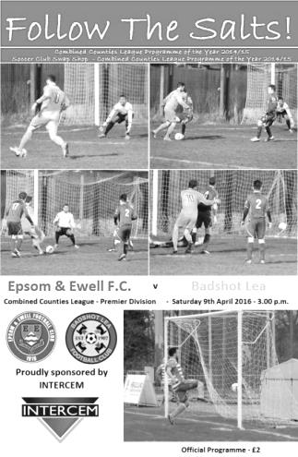
Despite the absence of the unwell Matt Tanton, the absent George Murphy and Sam Currie and the suspended Elliott Thompson and Adrian Jones, we still had far too much for a Badshot Lea team that were playing their third game in five days and apart from a slight wobble in the opening ten minutes of the second half, this was a fairly comfortable home win.

In goal Alistair Turpie reclaimed the jersey from a thankful Rob Hendry who started on the field alongside Kyle Hough this time. Daryl Cooper-Smith dropped to the bench, while James Taylor and Matt Ferdinando returned to the starting line-up.

We started with the benefit of a fairly strong wind blowing away from the clubhouse end and took full advantage with a goal in the fifth minute. Savvas 'Agi' Panayiotou had a great game against Guildford, following his scoring strike against Raynes Park and this time he scored again, receiving the ball on the edge of the area. His first effort on goal was blocked but the ball came back to him and he then rode a challenge and smashed the ball past Pat Kinsella from about 18 yards and into the bottom corner.

Hendry nearly made it 2-0 a minute later after a defensive error but his snapshot was inches wide and skimmed the side netting as it went past the post. Kinsella was then out to block well from Hough from a narrow angle and defied Panayiotou moments later after Hough had put him through on the left. All this and the game was only ten minutes old!

The visitors struck a couple of efforts towards goal, one of which dipped just over our crossbar but it was almost all Epsom as we continued to have our way in midfield and Panayiotou was nearly the provider again after being fed by a great ball from Hendry, but his low cross was cleared for a corner ahead of the incoming Matt Farrell.

Craig Hastings was not too far away with a header from Ferdinando's right wing free kick but that was our wide man's last contribution of the day as he landed heavily on an ankle that had been suspect going into the match and he limped off dejectedly after 23 minutes with Cooper-Smith coming on and Hendry moving out onto the right hand flank. The recently introduced substitute had a good chance with his first touch out on the left but his shooting lacked a little composure and he sliced his shot high and wide.

Next it was Bentley Graham who turned provider and he put Hough through on the left but Kinsella was there again, although in the 38th minute he could do nothing as a low ball in from the right from Hendry was latched onto by Hough who rounded the keeper and slotted home almost in one movement to double our lead.

We nearly scored a third in injury time after Graham's clever reverse pass to Hendry resulted

in the busy Kinsella having to make another fine save and it's no exaggeration to say that two-nil was the least we deserved at this stage. Maybe we thought it would be an easy second half but for some reason we didn't come out with the same intensity and the opposition started to fight back.

They reduced the arrears after 51 minutes. Panayiotou chased the Badshot right midfielder all the way back into his own half to win the ball, but after doing the hard work, he then promptly passed the ball straight to an opposition teammate who sent the ball over to the other side of the field where Gavin Muir had time to take a touch and slot the ball past the unlucky Michael Eacott and almost exactly between two covering defenders on the line. Eacott had only been on the field for two minutes after Turpie had aggravated an injury making a routine collection of the ball and had limped off.

This sparked us back into action and we should have made it 3-1 in the 58th minute when Cooper-Smith received the ball from the right wing; controlled it but then sent it wide from just 8 yards. Fortunately any concerns were short lived as we put a nice move together with a number of passes and this culminated in Panayiotou getting free on the left and he cut in at goal. His shot was well blocked by Kinsella but the loose ball fell to Farrell who drilled the ball into the net from a similar angle in the 65th minute.

Panayiotou was having another great game and has surely nailed down the left midfield berth for the remainder of the season and got free again, rounding the keeper but just knocked the ball too far and couldn't quite reach before it went out for a goal kick. Graham then set up Hough but he was robbed for a corner just as he was about to pull the trigger. Eacott needed to be alert soon after as a weak header back to him from Dan Dean required him to come out and gather the ball, but in truth this was not a busy day for the men at the back as we only faced one shot on target.

Our third substitute Tom Neale then had a shot well saved before we scored our fourth goal with the clock ticking into the 90th minute. Again Panayiotou was the provider after some really good football. All that was missing was some Spanish guy with a cape shouting olé as we passed the ball at will and then Agi turned and was through, cutting the ball back for Farrell to score his second of the day with an easy tap in. We nearly had time for an outrageous fifth as Neale put Cooper-Smith through and he reached the ball ahead of Kinsella, chipping the ball over him from the edge of the box but it dropped on to the roof of the net.

This was our most complete performance for a while and our third win in a row by at least three clear goals. If we can win at AFC Hayes on Tuesday we will go into the big final matches on a fine winning run. Will it be good enough? Well, even a run of wins from here on in requires a slip up elsewhere from both Camberley and Ashford so it is out of our hands, but all you can do is keep beating the sides we play and see where it takes us. For now, we still have a chance.

Team: Alistair Turpie, James Taylor, Reisse Griffin, Dan Dean (c), Craig Hastings, Bentley Graham, Savvas 'Agi' Panayiotou, Matt Farrell, Kyle Hough, Rob Hendry,
Matt Ferdinando

Subs: Daryl Cooper-Smith for Ferdinando (23), Michael Eacott for Turpie (49),
Tom Neale for Hendry (82)

From behind the goal
AFC Hayes 0-7 Epsom & Ewell
Combined Counties League – Premier Division - Tuesday 12th April 2016

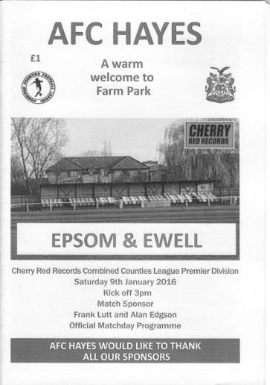
Super Salts score seven again!

Our 7-0 win at Farm Park marked the fifth occasion this season where we have scored at least five goals away from home in a league match. It is rare that an Epsom scoring feat pre-dates our fantastic 1974/75 season but this is one, matching the club record set in 1926/27. It was of course our second away "seven" of the season following the October win at Cove, but it should be remembered that it is an incredibly rare achievement and it was only the fourth time since World War Two that we have scored this many!!

As with any day where many goals were scored, there are also a few chances that went begging and we even had the luxury of resting Kyle Hough and Bentley Graham after an hour with a view to Saturday's important home match with Camberley Town. Equally importantly six different players found the net.

We made three changes from our convincing win over Badshot Lea. Michael Eacott replaced the injured Alistair Turpie, while Matt Tanton returned at left back, allowing Reisse Griffin to return to his more familiar right wing slot. Up front Daryl Cooper-Smith replaced Rob Hendry and his pairing with Griffin cut the home side apart on quite a few occasions.

We scored with our first attack on goal in the third minute. Cooper-Smith found space on the right and he then fought his way past defenders to cut the ball back for Griffin to open the scoring with a close range tap in. Six minutes later the positions were reversed as Griffin's dangerous low right wing cross skipped across the six yard box to Cooper-Smith who controlled the ball with his chest and as it fell he poked it just wide of the home custodian Dominic Quade.

We were causing havoc every time we went forward and Graham saw his shot deflected just wide before we scored our third in the 17th minute. A throw on from the left flank was flicked on by Cooper-Smith and Hough controlled the ball in stride, ran around the defender and drilled the ball low into the corner with his right foot. He could have passed to the unmarked Griffin who was stood nearby but Kyle hasn't reached this many goals without taking a few shots and his 197th for the club would be followed with another in the second half.

The home side looked quite nippy going forward themselves with their in-form striker Bradley Hand causing a few problems, but we mostly kept them at long range. A free kick was tipped over by Eacott after 20 minutes and three minutes later a far post corner was headed against our bar and away to safety. Eacott was then out to clear quickly ahead of Hand before he was required to tip a low shot around the post. It was just as well it was 3-0

at this point as it was a concerning spell.

But it wasn't long before we were attacking again and Cooper-Smith was put through but blazed the ball over the bar. Savvas 'Agi' Panayiotou then sent in a cross from the left but Quade was out quickly to smother the ball before Cooper-Smith could get the ball under control. The blitzkrieg continued with a quick Graham free kick that was played through to Hough, but he was a little wide and Quade stopped his shot for a corner, from which Farrell's powerful drive was deflected wide off a defender.

Another goal had to come and it duly arrived in the 41st minute with a flowing move with Cooper-Smith setting up Griffin on the right. His low ball in was held up by Hough who then laid it back for Panayiotou to stroke the ball into the bottom far corner from the edge of the area. Cooper-Smith nearly scored a great fifth goal but his chip from twenty-five yards was tipped over by the retreating Quade and as time expired we had a shout for a penalty when Mason Yorke clearly pushed Dan Dean out of the way, but the half time score of 4-0 was more than acceptable.

The onslaught continued straight away and with the clock just ticking into the 48th minute it was 5-0. a throw on from the right bounced over a couple of players and Hough lashed it goalwards. Quade got a touch to it and pushed the ball onto the post but it had just enough momentum to cross the line and nestle in the opposite side netting. Just as I was writing these notes down we scored a sixth as Farrell was on the end of some neat interplay and he had time to control the ball and fire home from 8 yards in the 50th minute.

Tom Neale and Rob Hendry entered the fray for Hough and Graham on the hour and Neale nearly scored from an extremely acute angle with Quade alert to tip the ball around the near post. Whether it was actually a shot or a sliced cross though, only our striker will know. Cooper-Smith struck at goal from thirty yards but this too was saved for a corner before Craig Hastings saw his headed goal from a free kick ruled out for offside. He was then given some time off as Alex McKay replaced him and in the 76th minute we scored our final goal of the evening. Griffin had a defender to beat but went round him and although wide, still got his shot in across goal where Quade made the save at full stretch but Neale was on hand to knock the rebound in from close range.

There were further opportunities. Neale was just wide with a volley from Griffin's cross before Hendry made good ground on the left and cut the ball back from the touchline for Cooper-Smith but his almost certain goal was stopped by a great goal line clearance from Yorke. In between those two chances Eacott finally got some mud on him as he was down to make a low save but it was all they had in the second half and there was an feeling of a mercy killing as the referee blew the final whistle just six seconds over time, despite our three substitutions!

All season I have been saying about the quality of some of the goals scored and there were some superb moves and finishes in this match. Griffin had his best performance for the club and even the home side were magnanimous in defeat, tweeting that we were the best team they had played all season. We now face a much stiffer challenge as Camberley visit on Saturday but surely it isn't possible to go into a game in better form!

Team: Michael Eacott, James Taylor, Matt Tanton, Dan Dean (c), Craig Hastings, Bentley Graham, Savvas 'Agi' Panayiotou, Matt Farrell, Kyle Hough, Daryl Cooper-Smith, Reisse Griffin

Subs: Tom Neale for Hough (57), Rob Hendry for Graham (61), Alex McKay for Hastings (75)

Club Records - 16th April
Date | Day | Competition |  | Opponents |  | Scorers
16/04/27 | Sat | Surrey Senior League | H | Aldershot Traction | 1-4 | R.Marlow
16/04/32 | Sat | London League | A | Chelmsford | 2-0 | B.Williams (2)
16/04/38 | Sat | London League | H | Wandsworth United | 6-1 | B.Solly (3), H.Pullen, J.Jones, G.Collins
16/04/55 | Sat | Corinthian League | A | Tilbury | 1-2 | L.Peake
16/04/60 | Sat | Corinthian League  Memorial Shield SF | H | Letchworth | 5-0 | B.Hawkins (2), N.Dearlove (2), K.MacDonald
16/04/74 | Tue | Surrey Senior League | A | Chessington United | 3-2 | T.Tuite (2), D.Ritman
16/04/77 | Sat | Athenian League 1 | H | Letchworth Garden City | 0-1
16/04/79 | Mon | Isthmian League 1 | A | Chesham United | 0-2
16/04/83 | Sat | Isthmian League 1 | A | Oxford City | 0-0
16/04/85 | Tue | Isthmian League  Premier Division | A | Carshalton Athletic | 0-3
16/04/88 | Sat | Isthmian League 2s | A | Chalfont St Peter | 2-0 | L.Harding, B.Perkins
16/04/91 | Tue | Isthmian League 2s | A | Egham Town | 0-3
16/04/94 | Sat | Isthmian League 3 | H | Clapton | 1-0 | N.Webb
16/04/01 | Mon | Isthmian League 3 | H | Croydon Athletic | 0-1
16/04/05 | Sat | Isthmian League 2 | A | Flackwell Heath | 1-2 | M.Owen
16/04/11 | Sat | Combined Counties  Premier Division | A | Horley Town | 2-0 | M.Smith, K.Hough (pen)
16/04/13 | Tue | Combined Counties  League Cup SF | A | Egham Town | 1-0 | M.Jarman
Historical Decades
90 years ago – Epsom Town F.C.
17/04/26 | Sat | Surrey Senior League | H | Camberley & Yorktown | 5-0 | R.Marlow (4), R.Sperring (pen)
80 years ago – Epsom F.C.
13/04/36 | Mon | London League | H | Tooting & Mitcham United | 2-1 | J.Jones, R.Edmonds
70 years ago – Epsom F.C.
19/04/46 | Fri | Friendly | A | Crawley | 1-1 | G.Brogdale
60 years ago – Epsom F.C.
14/04/56 | Sat | Corinthian League | H | Chesham United | 3-2 | J.Berry, T.Day, R.Colfar
50 years ago – Epsom & Ewell F.C.
11/04/66 | Mon | Athenian League 2 | A | Wingate | 1-1 | K.Welham
40 years ago – Epsom & Ewell F.C.
17/04/76 | Sat | Athenian League 2 | H | Uxbridge | 2-0 | J.Eales, P.Butler
30 years ago – Epsom & Ewell F.C.
19/04/86 | Sat | Isthmian League  Premier Division | H | Worthing | 3-3 | T.Tuite, R.Strong, J.Richardson
20 years ago – Epsom & Ewell F.C.
11/04/96 | Thur | Isthmian League 3 | H | Tring Town | 11-1 | A.Boxall (6), P.Meredith, D.Argent, A.Rawlinson, K.Webb, B.Forey
10 years ago – Epsom & Ewell F.C.
15/04/06 | Sat | Isthmian League 2 | H | Camberley Town | 0-4

History Corner - 16th April
90 years ago this week we defeated Camberley & Yorktown 5-0 in a bad tempered Surrey Senior League match. We cruised to a three goal half time lead but in the second half Reg Sperring was sandwiched between two visiting players, injuring his ankle. Then Collier for Camberley struck our man Reg Coleman and H.S. Streeter ran in and exacted retribution, leading to both receiving an early bath. Then the Camberley Captain was booked and at one point both teams were down to nine men. Sperring had the last word, coming back on the pitch later and scoring a penalty to add to the four that Reg Marlow had already scored! Camberley were described as a physical team back then. Two more narrow home wins would give us the League title for the very first time.

89 years ago today we slipped up at home to Aldershot Traction in a Surrey Senior League match. Arguably preoccupied with our key Good Friday win at Egham just 24 hours earlier, this was a bit of an anti-climax. Reg Marlow put us ahead but we were behind by half time and two more goals followed in the second half as we collapsed 4-1. The local papers described us as “tired” but it didn’t stop us from playing a friendly match at Sutton United on the Easter Monday! We lost that match also, but would win our remaining six league matches and then a League Cup Final at Egham to clinch a double, before departing for the London League.

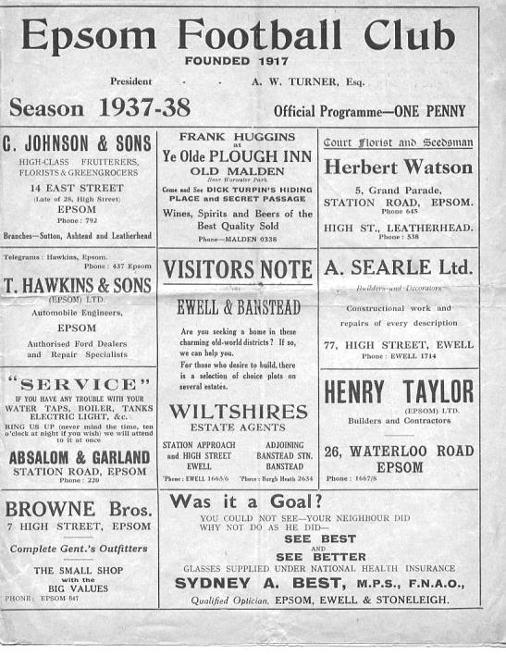
78 years ago today we crushed Wandsworth United 6-1 in a London League match with Basil Solly scoring a hat trick. Solly played firstly for Dulwich Hamlet before spending some time with Sutton United. However, he was dropped from the United squad for a match and promptly announced that he was joining Epsom. Even their own supporters sided with the player and a number of them even attended Solly’s debut at West Street against Finchley, ahead of their own team’s home match against Wealdstone! Wandsworth were put to the sword in front of one of the largest gates of the season and our team included centre-half Bryn Evans who played despite the death of his younger brother in a motorcycle accident in Oxfordshire the day before, stating that “he believed club interests came first”. (see programme right)

56 years ago today we defeated Letchworth by five goals to nil at West Street in the Corinthian League Memorial Shield Semi-Final. This was their League Cup competition and we would of course go on to win the Shield for the only time in our history just two weeks later. Bill Hawkins and the recently departed Norman Dearlove scored twice while Scottish Amateur International Ken MacDonald scored the other goal.

30 years ago this week we were battling relegation from the Isthmian League Premier Division and Worthing visited us, knowing that one of our two away League wins had come against them. We were a goal up at the half through Tommy Tuite and after 70 minutes it was still the only goal of the game but within 6 minutes were 2-1 down! Richard Strong forced an equaliser but we went behind again, only for Jimmy Richardson to secure a point with a late goal. I can recall a shot from Martin Gillings where he lifted the ball over the advancing keeper while 1-0 up but it just wouldn’t come down in time and thudded away off the crossbar! We went down at the end of the season.

Twenty Years Ago this week
Epsom & Ewell 11-1 Tring Town
Isthmian League – Division Three - Thursday 11th April 1996

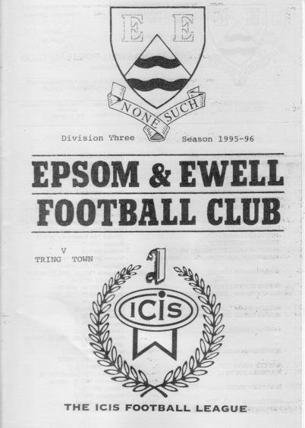
It is hard to believe that it is now twenty years ago that we defeated Tring Town at Merland Rise in a rearranged Thursday evening fixture.

The evening started late due to M25 traffic for our visitors and long before the end I’m sure they wished they had never arrived as we were ahead within 23 seconds and things got worse for Tring from that point onwards.

We kicked off towards the top goal at Banstead, our home ground back then, and I recall walking towards my usual position behind the goal. I had just reappeared from behind the main stand when the ball came in from the right wing and was forced it at close range by Kevin Webb and a second goal wasn’t long in arriving.

However, back then our free scoring line-up had a bit of an achilles heel. It was called our defence! We scored as many goals as the top two clubs that season, Horsham and Leighton Town, yet finished seventh, largely on the back of 14 draws in a 40 game season, a figure that only Kingsbury Town could beat. We weren’t too bad at the start of the season but following the loss of talented defender Barry Miller who went on to have a fine career at Doncaster Rovers amongst other places, we were a bit slow at the back, or maybe just a bit too attack minded. After all, regular full back Tim Smith, centre half Graham Meakin and Graham Morris all scored four times in open play this season, with Morris also adding a penalty to his tally.

So it came as no surprise when we conceded and at 2-1 the usual doubts began to surface. Fortunately they didn’t last too long as this was to be Andy Boxall’s night. Our skilful striker was arguably the most talented player to ever play for the club and he tied the visitors in knots, walking a couple into the net, one of which twisted the keeper in so many directions that he was injured as Boxall scored our fifth goal and had to go to hospital with a suspected dislocated hip! He would end up with six goals on the night, equalling the club record set by Reg Marlow, Leslie Marlow and Tommy Tuite.

The score was 6-1 at half time and it became eight by the hour mark, by which time they were down to ten men after a visitor had been sent off, somewhat harshly I recall, for foul and abusive language. At this point, both players and supporters smelt blood and an almost constant stream of attacks rained down on Tring as we stormed down

the hill at them.

However, as we reached the 85 minute mark the score remained 8-1 but three goals in the last five minutes ensured a memorable night that wouldn’t be forgotten by the 45 spectators present.

The next morning I remember being woken up by my good friend and Camberley Town supporter Barrie Funnell who had called to check that the result was not a misprint!

Our line-up that day contained many fine players but we were not even at full strength, missing Tony Boorman, Steve Smith and Stuart Miller, all of whom had played in Easter Monday’s 4-0 win over Camberley Town and our 3-1 defeat at Leighton Town on the Saturday. Incidentally, we also scored within the opening minute in that match and the one afterwards at home to Hornchurch!

Boxall would finish with 29 goals for the club that season, while another young lad who played and scored in that game would get 29 a few seasons later before departing for America. His name was Ben Forey.

Our line-up was: Dave Hyatt, Ben Forey, Dave Argent, Graham Meakin, Nigel Bennett, Graham Morris, Paul Meredith, Tony Hoy, Andy Boxall, Andy Rawlinson, Kevin Webb

Scorers: Andy Boxall (6), Kevin Webb, Paul Meredith, Dave Argent, Andy Rawlinson, Ben Forey

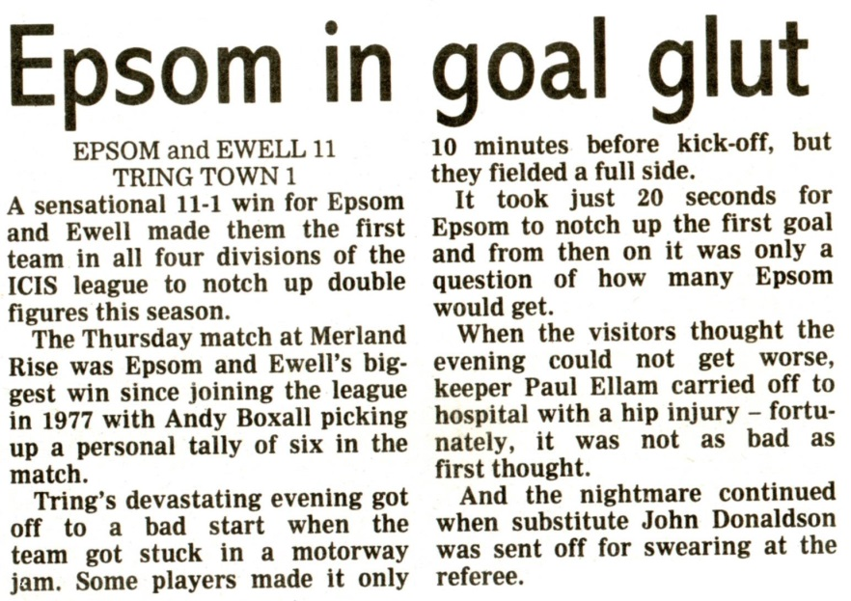
The Epsom Herald report is below:

Centre page for results

Centre page for results

Every Opponent A-Z
Over the years we have played many, many different opponents. Exactly how many is a difficult question, as it all depends on your definition. Are Camberley & Yorktown different to Camberley Town, or are Epsom Town different to Epsom F.C. or Epsom & Ewell F.C.?

In my analysis I have classed them as the same team, and will work through them all from A to Z. Some we have played many times, whilst others we have met just once or twice. Enjoy!

Shoreham: Played 3 - W2 D0 L1 - F7 A4 - PPG - 2.00 - Very Good

We have met Shoreham three times in our history, all of which were played at home, yet all three matches were at different home venues!

Our first encounter came on 3rd November 1990 and was a very distressing experience. Over the years we have had many meltdowns in the F.A. Vase, but this one might just trump the other more familiar defeats against Lingfield, Chichester, Herne Bay etc. Despite a late kick off due to one of the Linesmen having an accident on the way to the ground we led 2-0 at West Street at the break and were in complete control. We hadn’t conceded a single goal in our previous three matches, yet contrived to let three goals in to set a very low mark for the worst second half performance in living memory by our team! The fact that it was the Vase only seemed to make it harder to take.

The other two matches were in the F.A. Cup and both went our way. Andy Rawlinson and Joao Tome ensured a 2-1 half time lead at Merland Rise on 19th September 1998 and that’s how it finished.

We had to wait a while for our most recent meeting which was our very first match at Moatside, the home of Merstham F.C. A massive downpour heralded our welcome, although it had more or less stopped by kick off time and we opened our campaign there with a 3-0 win.

A Mark Jarman header in the 9th minute set us on our way although I was distracted slightly as at that precise moment he scored, I was stung on the neck by a wasp! (see picture)

We await the inevitable home Cup draw against Shoreham now that we are playing at Chipstead!

South Park: Played 8 - W6 D1 L1 - F17 A7 - PPG - 2.38 - Fantastic

It is now time for a very recent opponent; one that we have met eight times already, yet the first meeting was not even five years ago!

Our first meeting came on 12th November 2011 at Moatside. This was their first season in the Premier Division of the Combined Counties, following their promotion but they already looked like they would be tough opponents for all, and would remain so until being promoted as Champions in 2014. However, we defeated them 3-1 that day with Sam Robinson scoring his first two goals for the club and we repeated the scoreline on our first visit to Whitehall Lane on 28th February 2012 league; the most memorable moment being James Cottee’s opening goal for us, which won the Goal of the Season award in the programme.

In 2012/13 we faced them earlier than expected as the game was brought forward. They were in between F.A. Cup matches with a Fourth Qualifying round tie against Met Police to negotiate a week later and had got off to a flying start in the league so were warm favourites. They led within two minutes but we were soon back on terms through Kyle Hough who eventually completed his hat trick in our 3-1 win. It was becoming apparent that we had a good record over this team, and even when they got their first point off us in an end of season match on a Chipstead dustbowl it was only through a late equaliser.

Unfortunately, that was a significant point as it meant that of five good teams we were destined to finish fifth after leading for some of the way, although we gained a far more important victory on Friday 10th May 2013 when the teams met at Farnborough’s Cherrywood Road ground in the League Cup Final, where goals from Kyle Hough, Robbie Burns and Sam Currie gave us our first trophy in 32 years with a 3-0 victory.

In 2013/14 we were drawn together in the Third Round of the same competition on 21st January 2014 but despite trailing at the half, a Hough penalty and a James Taylor close range winner ensured that we would progress 2-1, thirty years to the day that we had last won on my birthday!

In our most recent meeting to date, they finally defeated us. We had started the season really well but faded away and by the time we met on 19th April 2014 they were close to clinching the title, while we were virtually certain to finish third. Two second half goals confirmed the 2-0 victory that in truth was the least they deserved on the day.

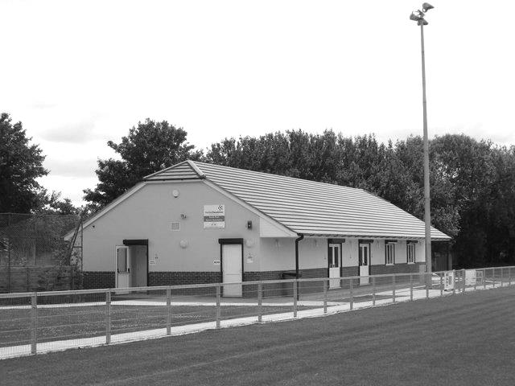
We still hold a perfect record against them on their own patch at Whitehall Lane and they sit in a midtable position at Step Four in the Ryman League South Division. There is every chance that we could meet them again in the not too distant future.

The main complex at Whitehall Lane

First Eleven Appearances - (max 43 including AFC Hayes – 12/04/16)
Name | Debut | 2015/16 |  |  |  | Career Totals
 |  | App | Sub | Total | Goals | App | Sub | Total | Goals
AJAYI Tayo* | 22/08/2015 | 0 | 2 | 2 | 0 | 0 | 2 | 2 | 0
COOPER-SMITH Daryl | 03/01/2015 | 17 | 5 | 22 | 10 | 26 | 8 | 34 | 16
CURRIE Sam | 04/08/2012 | 21 | 5 | 26 | 1 | 129 | 14 | 143 | 3
DAVISON Conor* | 22/08/2015 | 1 | 2 | 3 | 0 | 1 | 2 | 3 | 0
DEAN Dan | 02/08/2014 | 28 | 3 | 31 | 1 | 64 | 4 | 68 | 1
DOWNS Carl | 17/09/2011 | 5 | 1 | 6 | 0 | 99 | 14 | 113 | 2
EACOTT Michael | 02/08/2014 | 35 | 1 | 36 | 0 | 81 | 1 | 82 | 0
FARRELL Matt | 02/08/2014 | 41 | 1 | 42 | 10 | 82 | 4 | 86 | 17
FERDINANDO Matt | 20/09/2014 | 26 | 2 | 28 | 8 | 53 | 6 | 59 | 14
GRAHAM Bentley | 09/02/2016 | 13 | 1 | 14 | 2 | 13 | 1 | 14 | 2
GRIFFIN Reisse | 08/08/2015 | 24 | 6 | 30 | 2 | 24 | 6 | 30 | 2
HASTINGS Craig | 08/08/2015 | 35 | 4 | 39 | 0 | 35 | 4 | 39 | 0
HATFIELD Jamie | 11/11/2006 | 1 | 0 | 1 | 0 | 249 | 13 | 262 | 6
HENDRY Rob | 08/08/2015 | 30 | 9 | 39 | 12 | 30 | 9 | 39 | 12
HOUGH Kyle | 14/08/2007 | 33 | 4 | 37 | 27 | 329 | 19 | 348 | 198
JONES Adrian | 06/08/2011 | 4 | 1 | 5 | 0 | 24 | 1 | 25 | 0
KURDZIEL Jakub* | 29/08/2015 | 1 | 0 | 1 | 0 | 1 | 0 | 1 | 0
MARVELL Dale* | 15/01/2000 | 8 | 4 | 12 | 1 | 269 | 49 | 318 | 86
McGREGOR Alex* | 08/08/2009 | 7 | 3 | 10 | 2 | 179 | 59 | 238 | 29
MCKAY Alex | 20/12/2008 | 23 | 2 | 25 | 0 | 108 | 28 | 136 | 8
MURPHY George | 19/03/2013 | 2 | 1 | 3 | 0 | 68 | 7 | 75 | 3
NEALE Thomas | 13/10/2015 | 16 | 15 | 31 | 10 | 16 | 15 | 31 | 10
NEILL David* | 03/10/2015 | 1 | 1 | 2 | 0 | 1 | 1 | 2 | 0
NORTH Rhys | 16/08/2015 | 17 | 7 | 24 | 1 | 17 | 7 | 24 | 1
OLIVER Beckett* | 29/08/2015 | 5 | 11 | 16 | 0 | 5 | 11 | 16 | 0
PANAYIOTOU Savvas | 03/01/2015 | 12 | 5 | 17 | 4 | 28 | 8 | 36 | 7
ROBINSON Sam* | 22/10/2011 | 0 | 1 | 1 | 0 | 54 | 5 | 59 | 13
ROWE Steve | 27/08/2011 | 0 | 1 | 1 | 0 | 24 | 3 | 27 | 0
SMITH Matt | 08/08/2009 | 0 | 0 | 0 | 0 | 91 | 43 | 134 | 10
TANTON Matt | 02/08/2014 | 35 | 0 | 35 | 0 | 53 | 4 | 57 | 1
TAYLOR James | 26/08/2013 | 26 | 4 | 30 | 3 | 82 | 12 | 94 | 6
THOMPSON Elliott | 09/02/2016 | 4 | 7 | 11 | 0 | 4 | 7 | 11 | 0
TURPIE Alistair | 31/03/2016 | 2 | 0 | 2 | 0 | 2 | 0 | 2 | 0
Own Goal |  |  |  |  |  |  |  |  | 1
* Player has left the club

Camberley Town – History
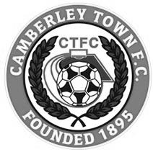
The football club was founded at St. Michael’s Church in Yorktown in 1895 and was initially named St. Michael’s, Camberley. The first trophy was won in the club's second season when Norwood & Selhurst were beaten 2-1 in the 1898 Surrey Junior Cup final. The club joined its first league, the East & West Surrey League, for the 1898-99 season and finished third.

In 1901 the club looked likely to fold for financial reasons but, after a public meeting, a new club named Camberley & Yorktown was formed by members of the St. Michael's committee. Camberley & Yorktown took the place of St. Michael's in the East & West Surrey League before joining the Aldershot Combination in 1902 followed by the Ascot & District League in 1903 where the club won four titles and finished second three times in the seven years spent in the league. The club went on to appear in three more Surrey Junior Cup finals, the first of which was in 1908 when Camberley & Yorktown took on Kingston at Woking and were beaten 2-0. The following season also resulted in a defeat in the final this time losing 1-0 to Selhurst Park. The 1909-10 season saw victory at last as Camberley & Yorktown defeated Sutton United 2-1 at Kingston.

The club moved to the West Surrey League in 1910 and in 1913 made their first appearances in both the F.A. Cup and F.A. Amateur Cup. On September 13th Camberley & Yorktown played host to Sutton United and won 5-3 in their first F.A. Cup match. The first F.A. Amateur Cup game was disappointing though as Camberley & Yorktown were soundly beaten 7-0 by the Royal Army Medical Corps, however the club went on to win the league title that season.

After World War I Camberley & Yorktown concentrated their efforts on the Aldershot Senior League until 1922 when the club submitted an application to join the newly formed Surrey Senior League. The application was accepted so Camberley & Yorktown became founder members of the league and remained in it for over 50 years. The club moved into their present ground at Krooner Park in 1923. The ground had been paid for from the winnings of a racehorse named 'Krooner' at Haydock Park in 1920. The 1930’s saw unequalled success at the club as they won the Surrey Senior League title three seasons running from 1931 to 1933 and appeared in the final of the Surrey Senior Cup in 1936 where they were beaten 3-1 by Wimbledon at Champion Hill, Dulwich.

After World War II Camberley & Yorktown dropped the 'Yorktown' part of their name. Krooner Park was not ready for use by the time the league resumed after the war so the club started the season at the London Road Recreation Ground which had been one of the grounds used before the move to Krooner Park. Success was hard to come by with only a victory in the Surrey Senior Charity Cup in 1952 against Chertsey and a further appearance in the final three years later to show for their efforts during the fifties and sixties.

In 1967 discussions took place regarding a merger between the club and the other senior club in the town, Camberley Wanderers. Wanderers had been formed as a youth football club in 1950 but moved into adult football in 1965 joining the Parthenon League but they had no ground of their own. On the 2nd of June 1967 the merger went through and both clubs became Camberley Town F.C. The first notable season as Camberley Town came in 1972-73 when third place was achieved in the league alongside an appearance in the League Charity Cup final at Weybridge where they lost 3-2 to Westfield. In a bid to bring a higher grade of football to the town the club joined the Spartan League in 1973 and installed floodlights in 1974. The official opening of the floodlights saw what is believed to be a record home attendance of around 3,500 people watch Camberley draw 1-1 with Malcolm Allison's Crystal Palace team.

In 1975 Camberley joined the Athenian League followed by the Isthmian League in 1977. Promotion to Division One of the Isthmian League was achieved in 1979 along with victory in the final of the Surrey Senior Cup where Leatherhead were beaten 4-1 after extra time at Imber Court. However, collapse soon followed and within three seasons Camberley found themselves back in the Athenian League and struggling on and off the pitch. Expansion of the Isthmian League in 1985 gave Camberley a route back into the league which was gratefully accepted.

In 1986 the Club enjoyed their best run in the F.A. Vase reaching the quarter finals where they went out to eventual winners Halesowen Town. The Aldershot Senior Cup was won in 1997 and 1998. 1997-98 also saw Camberley reach the Fourth Qualifying Round of the F.A. Cup equalling their best performance in the competition since the 1930's. In the league they missed out on promotion on the final day of the season. In 1998-99 Camberley went one better in the F.A. Cup reaching the First Round Proper for the first time where they were knocked out by Division 3 side Brentford.

Following the disbanding of the Isthmian League Second Division in 2006 Camberley were placed in the Combined Counties League and have since secured their best run of league placings for many years. In 2009 the club won the Combined Counties Premier Challenge Cup for the first time beating Worcester Park 3-0 in the final at Carshalton Athletic F.C.

Current first team manager Dan Turkington took the helm during 2012-13 season. The club finished in second place in the league in both 2014 and 2015. 2015 saw the club winning two cup competitions in one season for the first time. Colliers Wood United were beaten 2-1 after extra time in the Combined Counties Premier Challenge Cup final at Woking F.C. and Fleet Town were beaten on penalties after a 0-0 draw in the Aldershot Senior Cup final at Aldershot Town F.C.

Player Profile – Number 20 – Matt Ferdinando
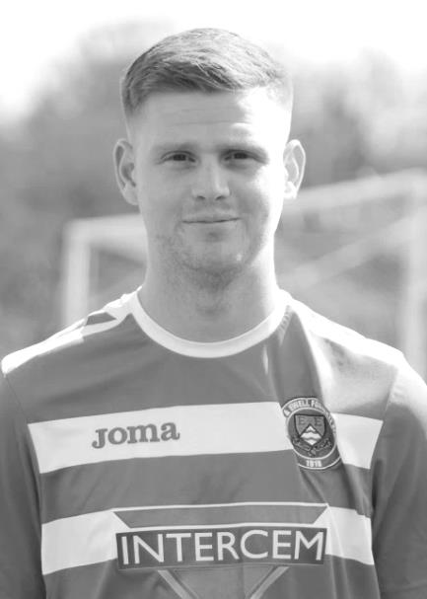
Our latest profile is from our entertaining attacking midfielder, Matt Ferdinando.

Age: 25

Position: Right midfield

Club supported: Chelsea

Favourite Meal: Chinese

Favourite Film: Snatch

Messi or Ronaldo: Messi

Favourite Drink: Carling

Favourite Ground played at: Stamford Bridge

Best moment for Epsom: Scoring THE overhead kick (goal of the season)

Matt’s Playing Stats: First Team Debut : 20/09/2014

Appearances: 53 - Sub: 6 - Total: 59 - Goals: 14

When did…?
…we last win four consecutive league matches by at least three clear goals?

The answer is all the way back to the 1974/75 season. We were obviously very good back then and had two league runs, one of four during late 1974, followed by another of five in the first three months of 1975.

…we last score five goals away from home in five League matches in a single season?

Most of our exceptional scoring records take us back to the 1974/75 season, but this one exceeds even that mark. The last time we did this was in our Surrey Senior League season of 1926/27 when we also did it five times in a season. We still have two more attempts to break that club record mark at Hanworth Villa and at relegation haunted Chessington & Hook United.

…we last score 16 goals in the space of three consecutive League matches, winning them all?

The last time we did this was in September / October 1974 when we scored 17, including a 9-0 home win over Cobham! We got 16 in April 1996 but didn’t win all three.

…we last score 19 goals in the space of four consecutive League matches?

See above – 21 goals in four games. The 9-0 win was accompanied by 4-0 Wandsworth (A), 4-1 Cobham (A) and 4-0 Wandsworth (H)

…we last score 15 goals in the space of three consecutive away League matches?

The last time we did this was in March / April 1975 when we scored 17, including a 9-0 win at Whyteleafe!

Combined Counties League Premier Division Opponents
All-time Records
inc Tuesday 12th April | P | W | D | L | F | A | PPG | GD | Best  Win | Worst  Loss
Spelthorne Sports* | 5 | 4 | 1 | 0 | 15 | 6 | 2.60 | +9 | 6-2 | -
Sutton Common Rovers | 10 | 8 | 1 | 1 | 27 | 12 | 2.50 | +15 | 4-0 | 1-4
Horley Town | 28 | 19 | 5 | 4 | 62 | 30 | 2.21 | +32 | 6-0 | 1-3
Colliers Wood United | 21 | 14 | 2 | 5 | 45 | 28 | 2.10 | +14 | 4-0 | 0-3
Westfield | 18 | 11 | 3 | 4 | 39 | 29 | 2.00 | +10 | 6-1 | 0-4
Bedfont Sports | 9 | 5 | 2 | 2 | 13 | 10 | 1.89 | +3 | 3-0 | 0-4
Farnham Town | 13 | 7 | 2 | 4 | 23 | 22 | 1.77 | 0 | 3-1 | 1-4
Guildford City | 16 | 9 | 1 | 6 | 32 | 22 | 1.75 | +10 | 5-1 | 1-5
Raynes Park Vale | 26 | 13 | 5 | 8 | 57 | 36 | 1.69 | +21 | 6-1 | 0-2
Knaphill | 6 | 3 | 1 | 2 | 11 | 8 | 1.67 | +3 | 4-1 | 1-2
Hanworth Villa | 13 | 6 | 3 | 4 | 31 | 22 | 1.62 | +9 | 5-0 | 1-4
Cove | 34 | 15 | 9 | 10 | 75 | 55 | 1.59 | +20 | 7-0 | 1-6
Chessington & Hook | 27 | 11 | 9 | 7 | 52 | 41 | 1.56 | +11 | 6-0 | 1-3
Camberley Town* | 87 | 38 | 21 | 27 | 156 | 120 | 1.55 | +36 | 9-1 | 0-4
Hartley Wintney | 10 | 4 | 3 | 3 | 25 | 17 | 1.50 | +8 | 5-0 | 2-4
Badshot Lea | 17 | 7 | 3 | 7 | 31 | 33 | 1.41 | -5 | 4-1 | 0-4
Windsor | 47 | 18 | 12 | 17 | 87 | 88 | 1.40 | -1 | 4-0 | 0-6
Redhill | 33 | 14 | 2 | 17 | 63 | 69 | 1.33 | -6 | 7-2 | 2-8
Chertsey Town | 47 | 17 | 5 | 25 | 70 | 86 | 1.19 | -16 | 3-0 | 0-7
AFC Hayes | 8 | 2 | 2 | 4 | 16 | 15 | 1.00 | +1 | 7-0 | 0-3
Ashford Town (Mx) | 17 | 4 | 2 | 11 | 22 | 44 | 0.82 | -22 | 3-0 | 0-5
Total* | 492 | 229 | 94 | 168 | 952 | 793 | 1.59 | +159 | - | -
* includes one abandoned match v Camberley and one loss on penalties v Spelthorne

Player Sponsorship
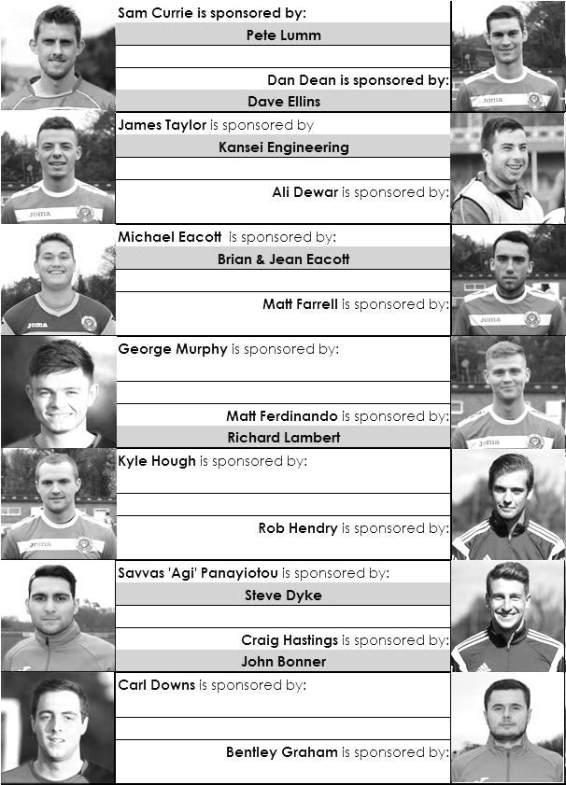

Here is the current list for the 2015/16 season showing all of our players and Management that are currently available for sponsorship this season.

Sponsorship costs just £40 and it is easy to do. Just select a player who has not been previously sponsored and let a Committee Member know that you would like to sponsor them. Beware though. Until we have received the money it is possible for someone to jump in front of you, so don’t delay, sponsor today!
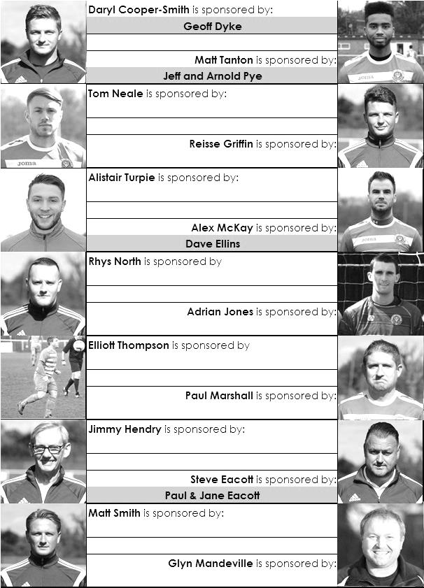

Match and Ball Sponsorships – 2015/16
Opponent | Date | Match Sponsor | Match Ball Sponsor
Hoddesdon Town | 18/07/15 | Geoff Dyke
Windsor | 08/08/15 | Club President - Stella Lamont
Erith & Belvedere (FAC) | 16/08/15 | Committee Member - Mike Lovett
Raynes Park Vale | 31/08/15 | EEFC Management Committee
Colliers Wood United | 08/09/15 | Bookham Building Shop – www.buildingshop.co.uk
AFC Hayes | 19/09/15 | John Bonner
Farnham Town | 26/09/15 | Ezara and Inaya Beddoe – our youngest supporters!
Chertsey Town | 17/10/15 | Club Media Officer – Richard Lambert
Dorking Wanderers (SSC) | 20/10/15 | Tony Ferdinando
Chessington & Hook United | 07/11/15 | Paul Merritt
Hanworth Villa | 21/11/15 | Maggie Beddoe
Guildford City | 05/12/15 | Pete Lumm
Sutton Common Rovers | 19/12/15 | Marvin Hough
Ashford Town (Mx) (LC) | 12/01/16 | Pete Beddoe & Steve Dyke
Redhill | 02/02/16 | David Lawton
Bedfont Sports | 13/02/16 | Bookham Building Shop – www.buildingshop.co.uk
Hartley Wintney | 23/02/16 | EEFC Management Committee
Horley Town | 27/02/16 | Jeff and Arnold Pye
Spelthorne Sports | 01/03/16 | In memory of Chris Henry
Knaphill | 12/03/16 | Marvin Hough
Cove | 15/03/16 | Mark & Carmel Murphy
Westfield | 26/03/16 | Nathan Lambert
Badshot Lea | 09/04/16 | Tony Coome
Camberley Town | 16/04/16 | Marvin Hough
Ashford Town (Mx) | 30/04/16 | Club President - Stella Lamont
Ashford Town (Mx) | 30/04/16 | Brian Eacott | Steve Dyke
For League, League Cup and Surrey Senior Cup Matches:
Match sponsorship - £40.00 Match ball sponsorship - £25.00. Combined £55.00.

We can still take more sponsors – Any game can have more, or why not sponsor a player?

Sponsorship includes: ( x2 for match, x3 for match and ball )

Admission, programmes, hospitality, advertising and mascot for the day (if required ).
If you are interested, just speak to a Committee Member, or drop me an email at: richard.c.lambert@gmail.com

We also thank our Kit Sponsors INTERCEM

Salts Super Six Predictor
The Salts Super Six Predictor Competition is live again and the tickets are on sale at today’s game to the left of the gate. We have now had three Super Six winners but the jackpot is building up again already!

The competition is easy to play! To win, you simply need to predict the results of the six matches correctly from the three options, fill in the form and make sure it is back with our sellers before the deadline on the ticket.

If you are a club regular, you just need to place your name on the sheet, although if you aren’t, then we’ll need a contact number from you too. We will announce any winners on the website very quickly, so don’t worry we won’t miss you!
The jackpot is already at £180 and who knows how high it could go this time!

Please note that if there is more than one winner, the prize pot would be shared between the winners. All you need to do now is have a go, as many times as you like!

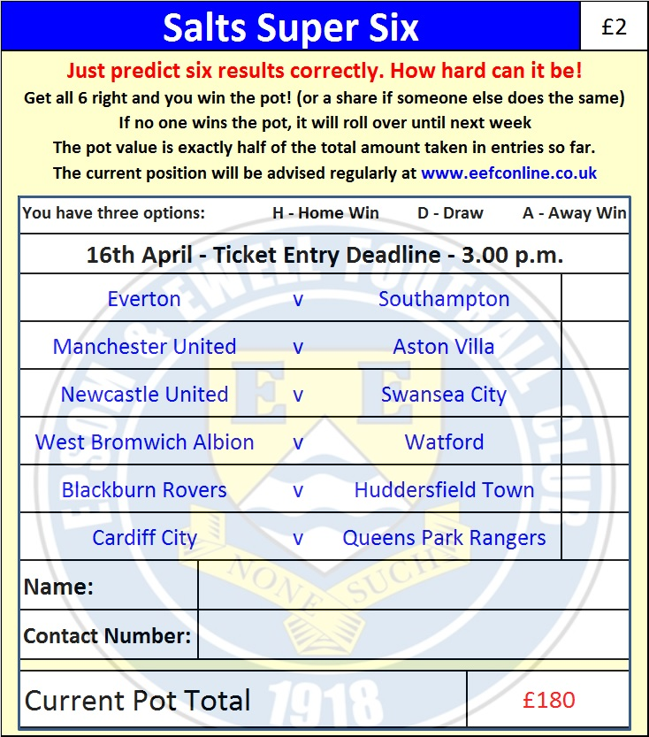

Good luck!

Combined Counties League – Premier Division
Saturday, 16th April 2016 - Kick-off 3.00 p.m.
Epsom and Ewell  (Royal Blue & White hoops) | V |  | Camberley Town  (Red and White)
Squad | NUMBERS
Michael Eacott |  |  | Craig Bradshaw
© Sam Currie |  |  | Matthew Humphrey
Matt Tanton |  |  | Bobby Dormer
Dan Dean |  |  | Matthew Bunyan ©
Craig Hastings |  |  | Carl Garstang
Bentley Graham |  |  | Nick Sowden
Reisse Griffin |  |  | Chris Ellis
Matt Farrell |  |  | Doug Ford
Kyle Hough |  |  | Marcus Cousins
Rob Hendry |  |  | Eli Ogunseye
Matt Ferdinando |  |  | Perry Coles
Rhys North |  |  | Dave Hill
James Taylor |  |  | Jamie Hoppitt
George Murphy |  |  | Robert Lazarczuk
Tom Neale |  |  | James Hubbard
Savvas ‘Agi’ Panayiotou |  |  | Dean Greenwood
Alistair Turpie |  |  | Christopher Ellis
Alex McKay |  |  | Keith Emmerson
Adrian Jones |  |  | Daniel Jewell
Carl Downs |  |  | Alexander Penny
Elliott Thompson |  |  | Bradley Timson
Glyn Mandeville | MANAGER |  | Dan Turkington
Matt Smith | ASSISTANT
Steve Eacott / Alex McKay / Jimmy Hendry | COACHES / PHYSIO |  | Sam Rafique /Dean Greenwood / Mark Whiteley / Andy Meade
REFEREE: M.Hayden (Epsom)
ASSISTANTS: J.Crichlow (Carshalton), P.Crichlow (Carshalton)
Today’s Match and Match Ball are sponsored by former player Marvin Hough, father of our striker Kyle

OUR FINAL VISITORS TO HIGH ROAD THIS SEASON ARE:
Ashford Town (Mx)
Saturday 30th April 2016 - Kick-off 3.00 p.m.
Combined Counties League – Premier Division

